KARABÜK CENTER ACCOMMODATION
PLACES | LOCATION | PRICES | NOTE
Karabük Öğretmenevi  (Capacity: 30 room)  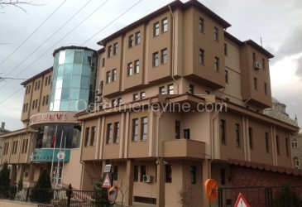 | Karabük Merkez  Yeşil Mahalle Taşkent Caddesi No:34 Karabük  (370) 415 24 11  https://karabukogretmenevi.com.tr/
Polis Evi  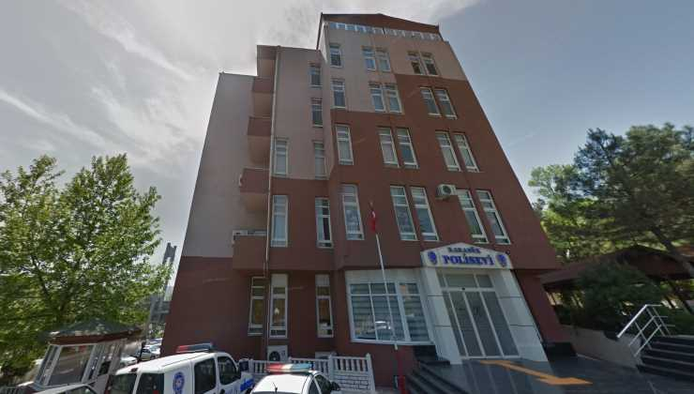 | Karabük Merkez  Ergenekon Mahallesi,  Ergenekon Cad. No. 14  Merkez/KARABÜK  (0370) 412 61 20

SAFRANBOLU CENTER ACCOMMODATION
PLACES | LOCATION | PRICES | NOTE
SAFRANBOLU ÖĞRETMENEVİ  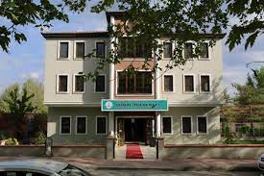 | Safranbolu Merkez  Yeni Mahalle Ünsal Tülbentçi Sk. No. 8  Safranbolu/KARABÜK  (370) 725 24 00
BAĞLAR SARAY OTEL  (Capacity: 42 room)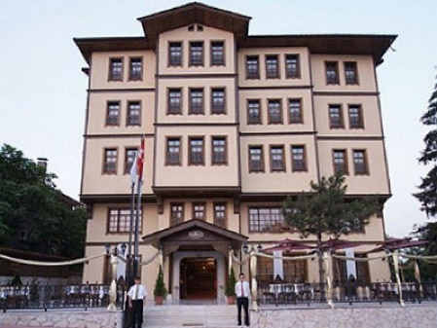 | Safranbolu Merkez  Yenimahalle, No:102, Sadri Artuç Cd., 78600 Safranbolu /KARABÜK  (0370) 725 50 78  http://www.baglarsaray.com.tr | Single room: 600 TL  Double room: 800 TL  3-person room: 1000 TL  Breakfast+VAT | Discounts will be applied to participants
ZALİFRE OTEL  ONLY 8-9 OCTOBER  (Capacity 10 rooms on relevant dates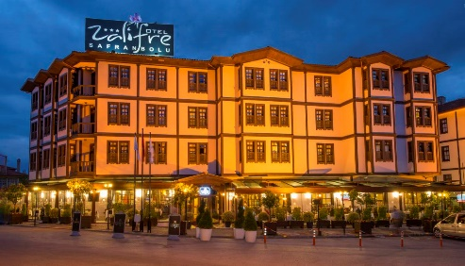 | Safranbolu Merkez  Barış Mahallesi, Araphacı Sokak, No: 77/A Safranbolu/KARABÜK  (0370) 725 47 18  http://www.zalifreotel.com | For 8-9 October:  Single room: 500 TL  Double room: 750 TL  3-person room: 900 TL

SAFRANBOLU OLD BAZAAR ACCOMMODATION
 | LOCATION | PRICES | NOTE
ARİF BEY KONAK& OTEL  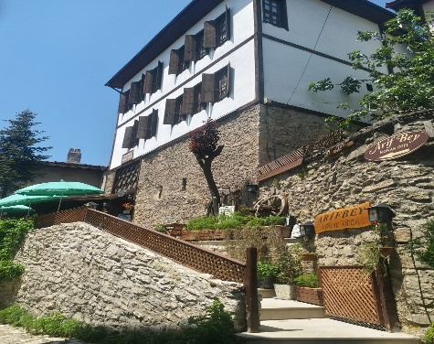 | Eski Çarşı  Akçasu Mah. Kaçak Sk. No. 3  Safranbolu/KARABÜK  Tlf: 0 370 712 32 42 | Single room: 400 TL  Double room: 600 TL  3-person room: 750 TL  Prices include VAT and accommodation tax | 12% discount will be applied when the event invitation is shown.
ASMALI KONAK  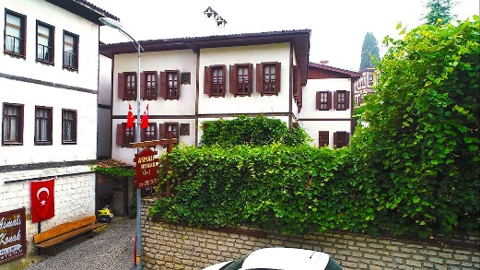 | Eski Çarşı  Hacı Halil Mh.  Asmazlar Cad. No. 13  Safranbolu/KARABÜK  0 370 712 74 74  https://asmalkonakotel.business.site/ | Single room: 450 TL  Double room: 600 TL  3-person room: 700 TL  Room for 4 people: 850 TL | Discounts will be applied to participants
BABAHAN KONAKLARI  (Capacity 11 room)  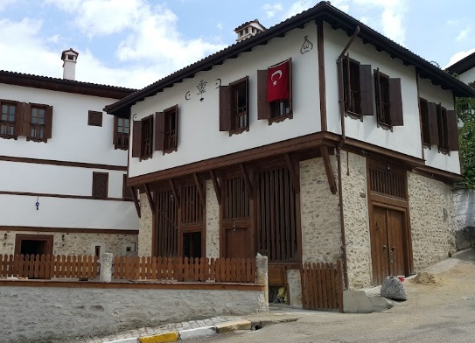 | Eski Çarşı  Babasultan Mahallesi  Şerbetçi Sokak No: 3  Safrarnbolu/KARABÜK  0 370 712 34 44  https://www.babahankonaklari.com/ | Single room: 300 TL  Double room: 500 TL  (Children under 7 are free) | Discounts will be applied to participants
CİNCİ HAN KERVANSARAY OTEL  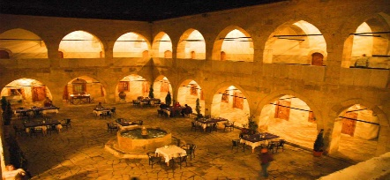 | Eski Çarşı  Çeşme Mah.  Cinci Han Sk.  No:10  Safranbolu/KARABÜK  http://www.cincihan.com/ | Standard double bed double room + breakfast 750 TL  Standard room twin bed single room + breakfast 600 TL  Suite room double bed + breakfast  1 000 TL | 10% discount will be applied when the event invitation is shown.
ÇAKIROĞLU KONAK  (Capacity 10 room)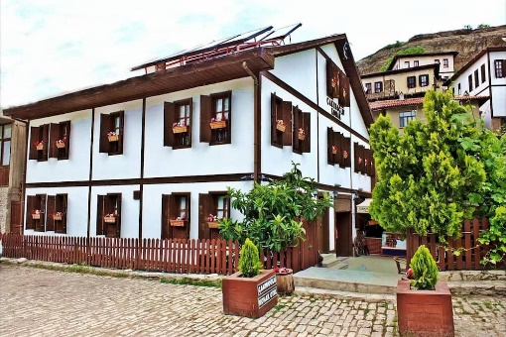 | Eski Çarşı  Babasultan Mah. Celal Bayar Cad.  No. 12  Safranbolu/KARABÜK  O 370 712 38 36  https://www.cakiroglukonak.com/ | Single room: 360 TL  Double room: 600 TL  3-person room: 800 TL  Prices include VAT and accommodation tax. | A 12% discount will be made upon submission of an invitation to Karabuk University.
ÇEŞMELİ KONAK GARDEN  (Capacity 20 room)  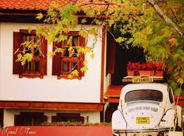 | Eski Çarşı  Babasultan Mah.  Celal Bayar Cad. No: 38  Safranbolu/KARABÜK  Tlf: 0 370 725 44 55  http://www.cesmelikonak.com.tr/ | Single room: 400 TL  Double room: 500 TL  3-person room:  600 TL | Discounted price for UCEK participants
EBRULU KONAKLAR  (Capacity 37 room)  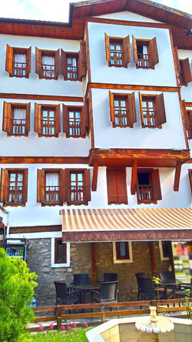 | Eski Çarşı  Babasultan Mah. Hıdırlık Yokuşu Sk.  Safranbolu/KARABÜK  0 370 712 07 14  https://www.ebrulukonak.com/ | Single room: 400 TL  Double room: 550 TL  3-person room:  800 TL | There will be a 15% discount with the presentation of the event invitation.
GÜNEŞ KONAK OTEL  (Capacity 8 room)  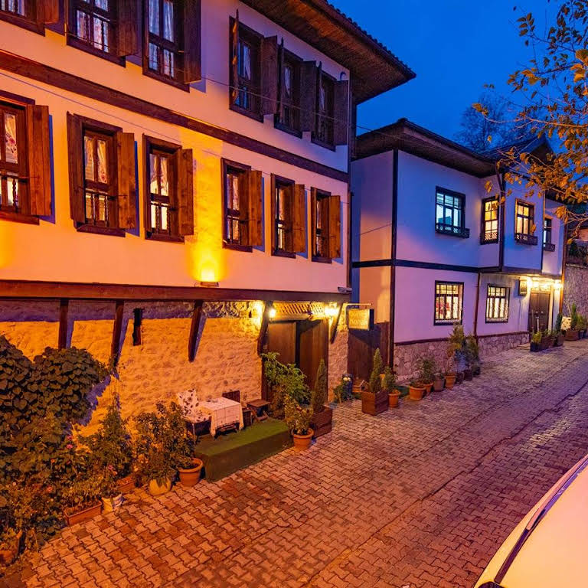 | Eski Çarşı  Musalla Mahallesi  Mezarlık Sokak  No:11  Safranbol/KARABÜK  0 541 712 78 79  http://guneskonakotelsafranbolu.com/ | Double room: 800 TL  3-person room:  1.000 TL | 20% discount will be given with the presentation of the event invitation.
KÜRKÇÜ KONAK  (Capacity 6 room)  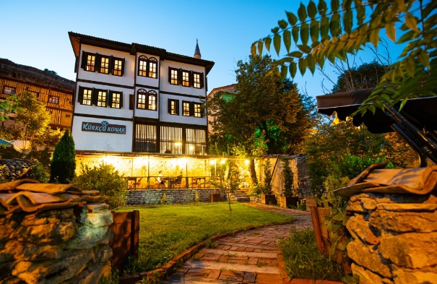 | Eski Çarşı  Akçasu Mah. Dağdelen Cami Yanı No:2 Safranbolu/KARABÜK  0 370 712 03 03  http://www.kurkcukonak.com/safranbolu-konak-otel.html | Double room: 700 TL  3-person room: 850 TL | 10% discount will be applied when the event invitation is shown.
ŞERBETÇİ GARDEN OTEL  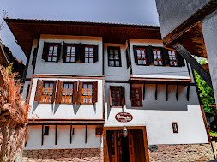 | Eski Çarşı  Akçasu Mah. Kaçak Sk. No: 29 Safranbolu/KARABÜK  Tlf: 0 532 573 52 03  https://serbetcigardenkonak.business.site/ | Single room: 400 TL  Double room: 600 TL  3-person room: 800 TL  Prices include breakfast + VAT and accommodation tax. | A 12% discount will be made with the submission of an invitation from Karabuk University.

THERE ARE MANY MORE HOMES WHERE YOU CAN ACCOMMODATE IN SAFRANBOLU OLD BAZAAR.
CONTACT INFORMATION CAN BE FOUND ON THE INTERNET.

